CSA1715-ARTIFICIAL INTELLIGENCE
LAB PROGRAMS
14-07-2026
- Write the python program to solve 8-Puzzle problem.

Aim
To write a Python program to solve the 8-Puzzle Problem using the Breadth-First Search (BFS) algorithm.

Algorithm
- Define the goal state of the 8-puzzle.
- Read the initial state from the user.
- Create a queue and insert the initial state along with its path.
- Maintain a visited set to avoid revisiting the same states.
- Remove the front state from the queue.
- If the current state matches the goal state, display the solution path and terminate.
- Find the position of the blank tile (0).
- Generate all possible valid moves (Up, Down, Left, Right) by swapping the blank tile.
- If the new state has not been visited, mark it as visited and add it to the queue with the updated path.
- Repeat Steps 5–9 until the goal state is found.

Program
from queue import Queue
goal=[[1,2,3],[4,5,6],[7,8,0]]
def show(a):
for i in a:
print(*i)
print()
def find(a):
for i in range(3):
for j in range(3):
if a[i][j]==0:
return i,j
start=[]
print("Enter initial state:")
for i in range(3):
start.append(list(map(int,input().split())))
q=Queue()
q.put((start,[start]))
v={str(start)}
while not q.empty():
s,path=q.get()
if s==goal:
print("\nSolution:")
for p in path:
show(p)
break
x,y=find(s)
for dx,dy in [(-1,0),(1,0),(0,-1),(0,1)]:
nx,ny=x+dx,y+dy
if 0<=nx<3 and 0<=ny<3:
t=[r[:] for r in s]
t[x][y],t[nx][ny]=t[nx][ny],t[x][y]
if str(t) not in v:
v.add(str(t))
q.put((t,path+[t]))
Input
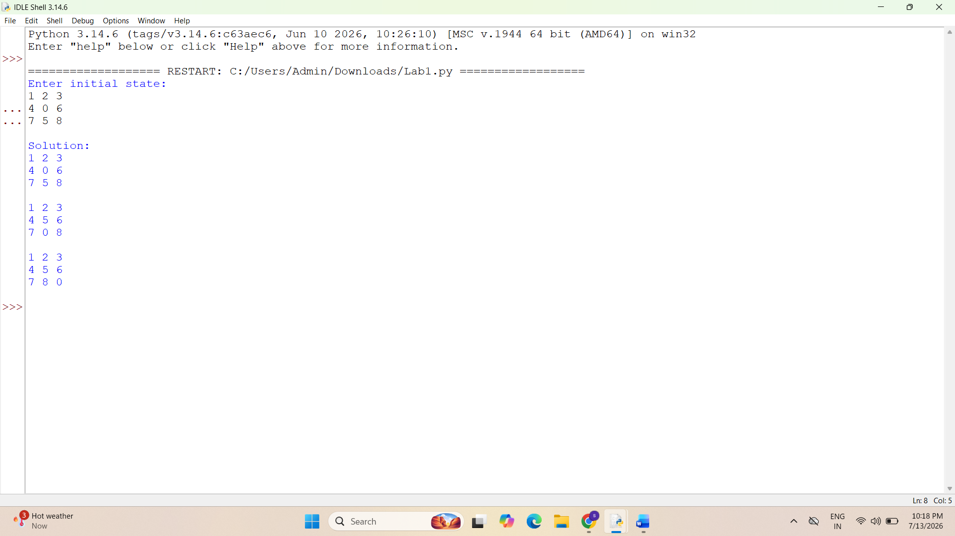
Output

Result:
Thus, the Python program to solve the 8-Puzzle problem was executed successfully and the desired output was obtained.

